How to add assertions in SOAP UI:

Create a new project:

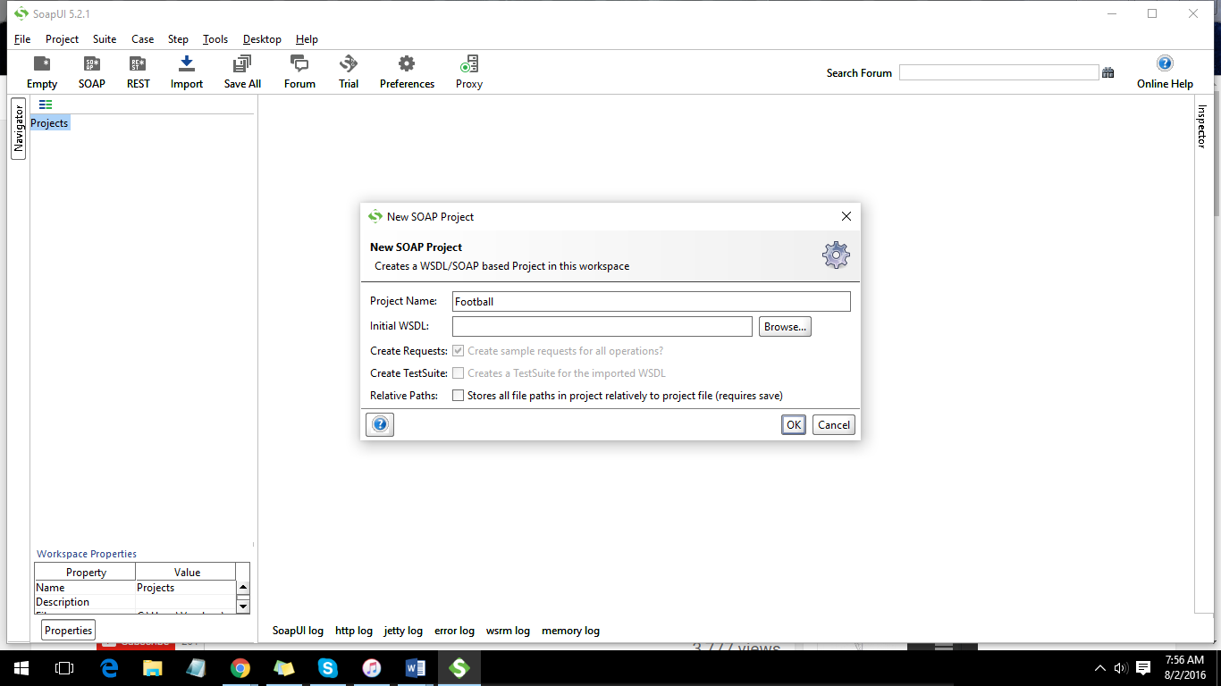

Add the WSDL file:C

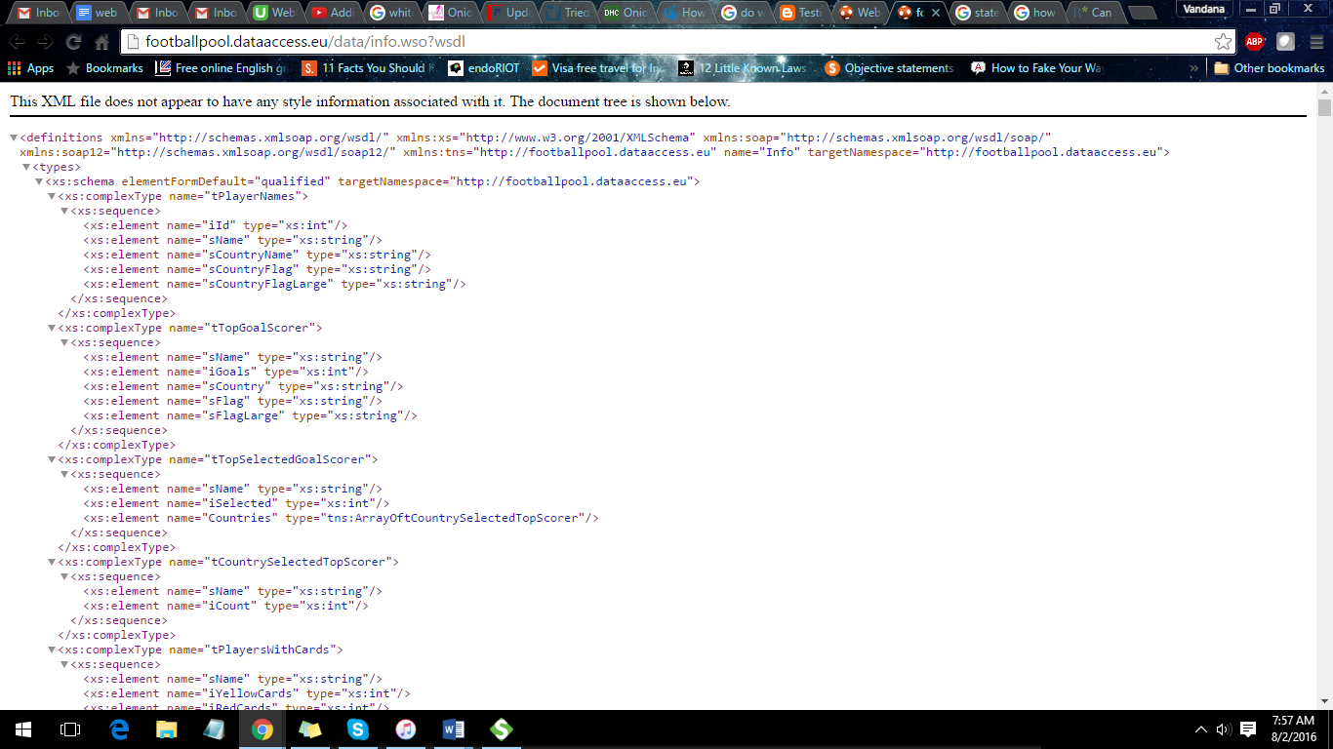

Copy the WSDL link and click on ok to create a new project.

A new project is created.

When we run a request, we can see the response in the right pane:

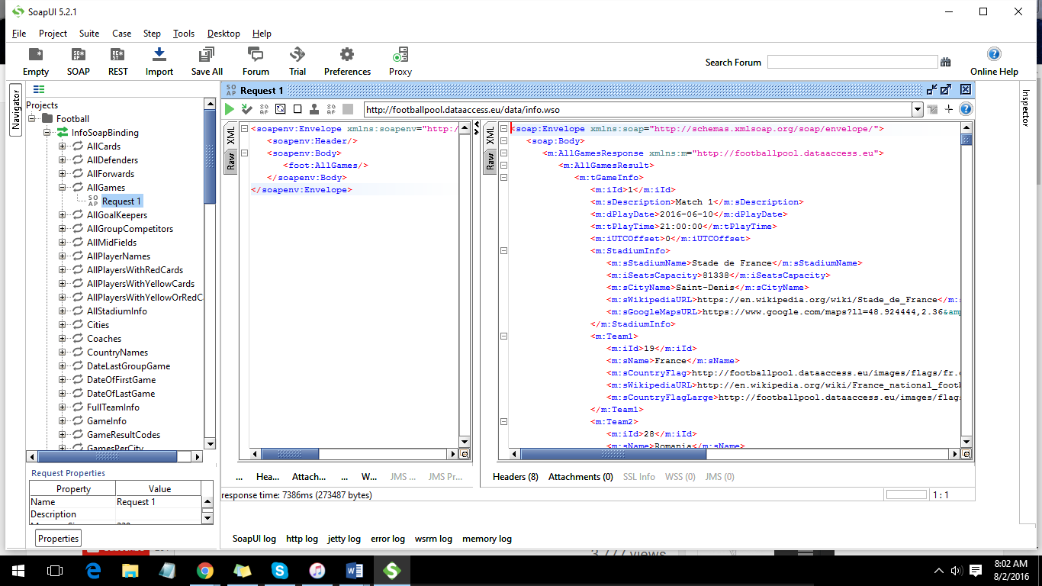

To add assertions:

Create a test case and a test suite:

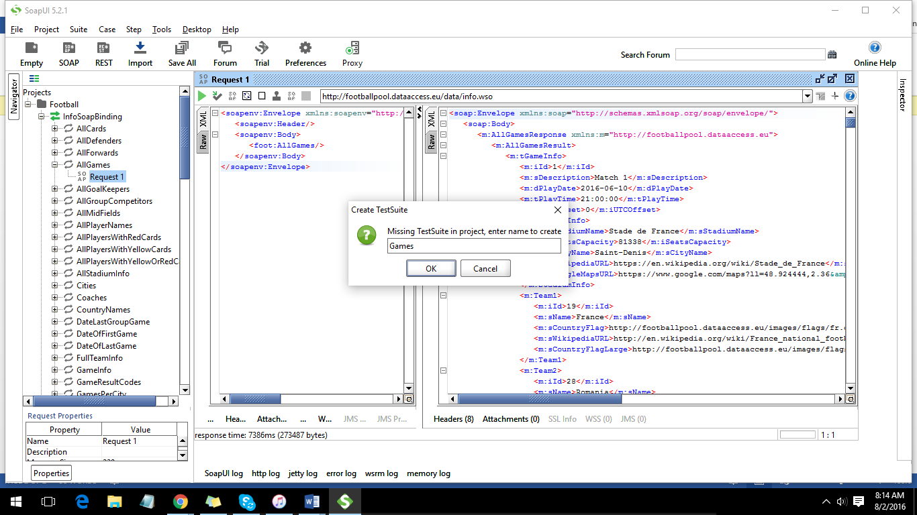

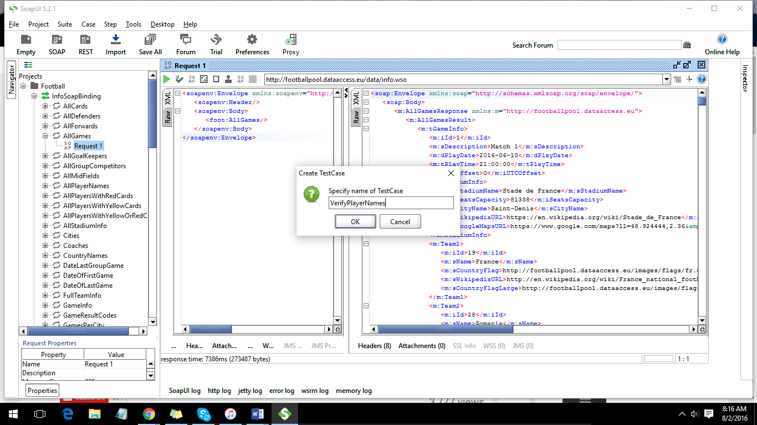

A test case is created:

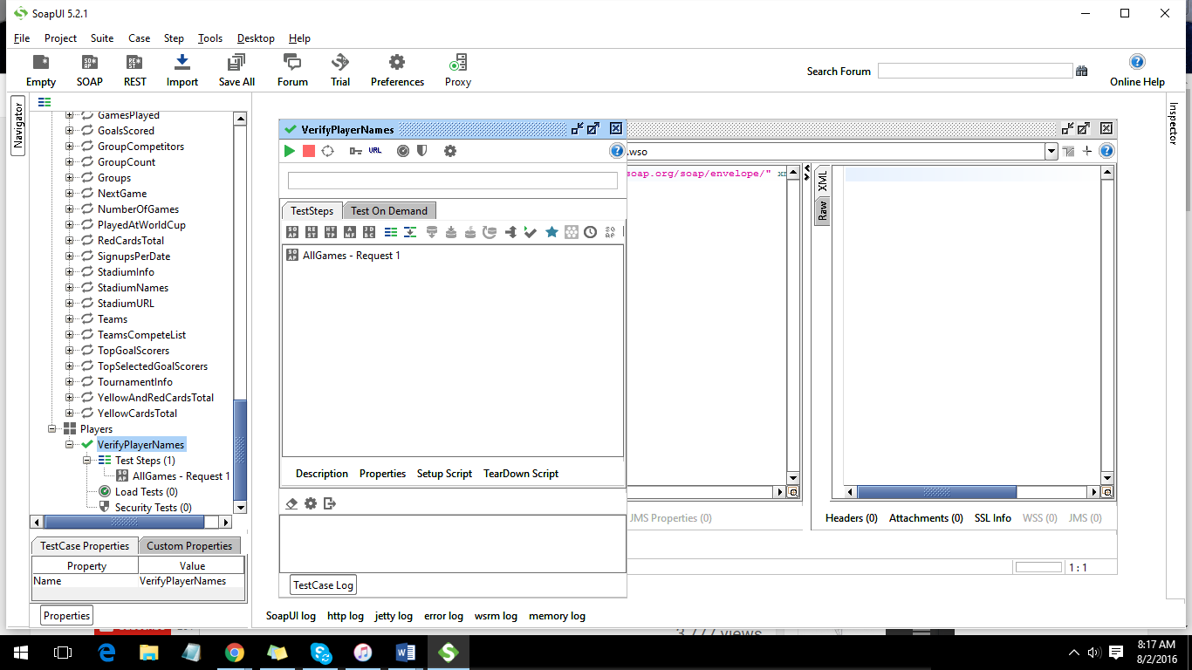

Created a test case called verifying country names:

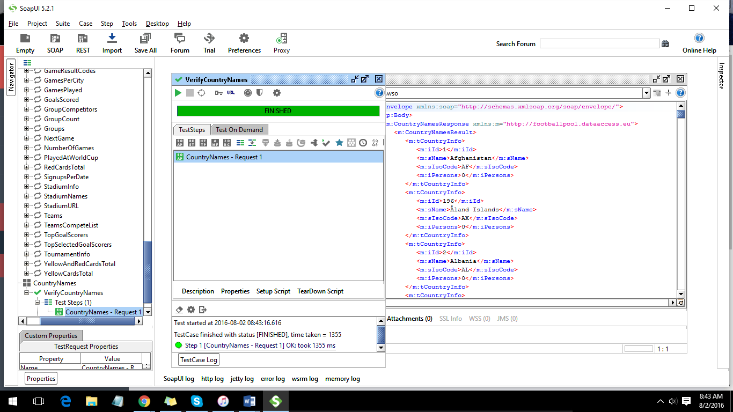

Steps to create assertion:

Click on add an assertion, a window appears like this:

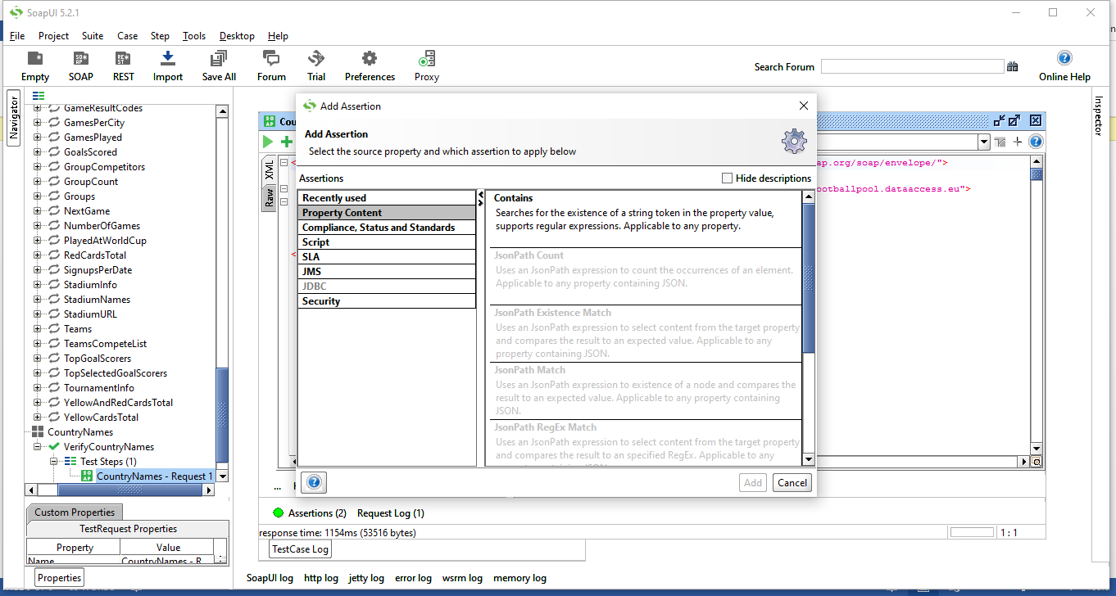

To check if a country is in the list, we can check using contains function:

Write the country name you want check in the box like below:

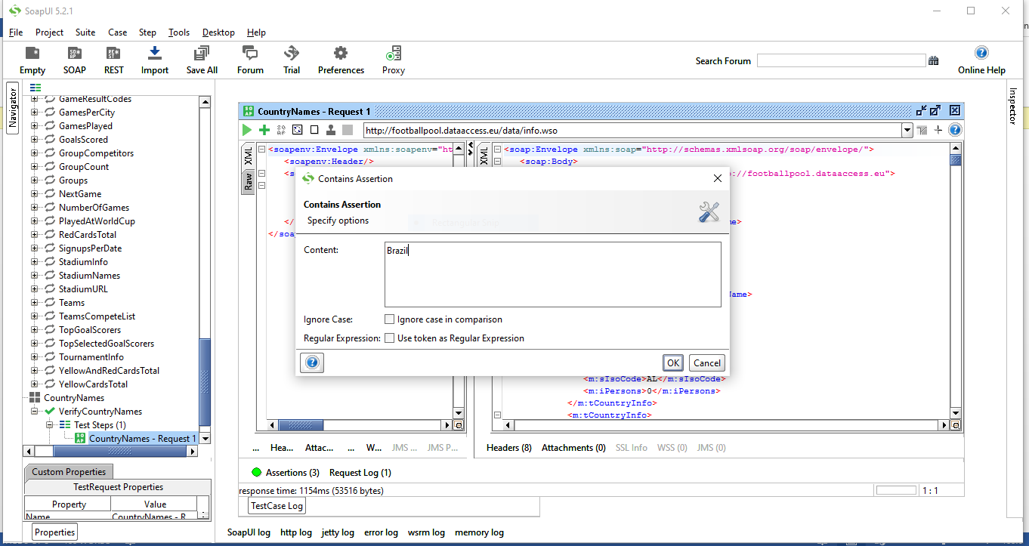

If Brazil is present in the list, we can see the result as below:

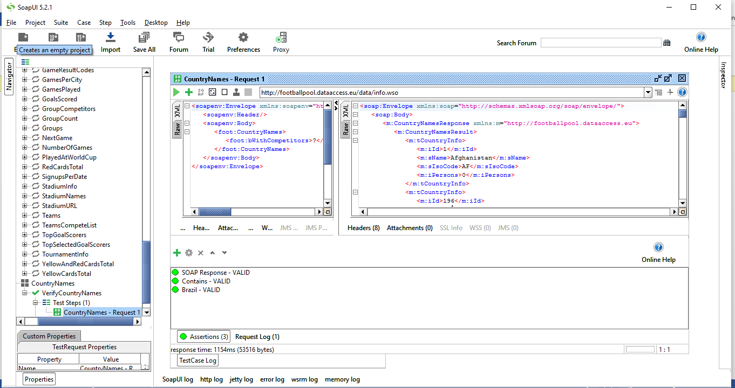

We can see a VALID status in the assertion pane.

To check the NOT Contains functions, repeat the above steps and choose NOT CONTAINS function:

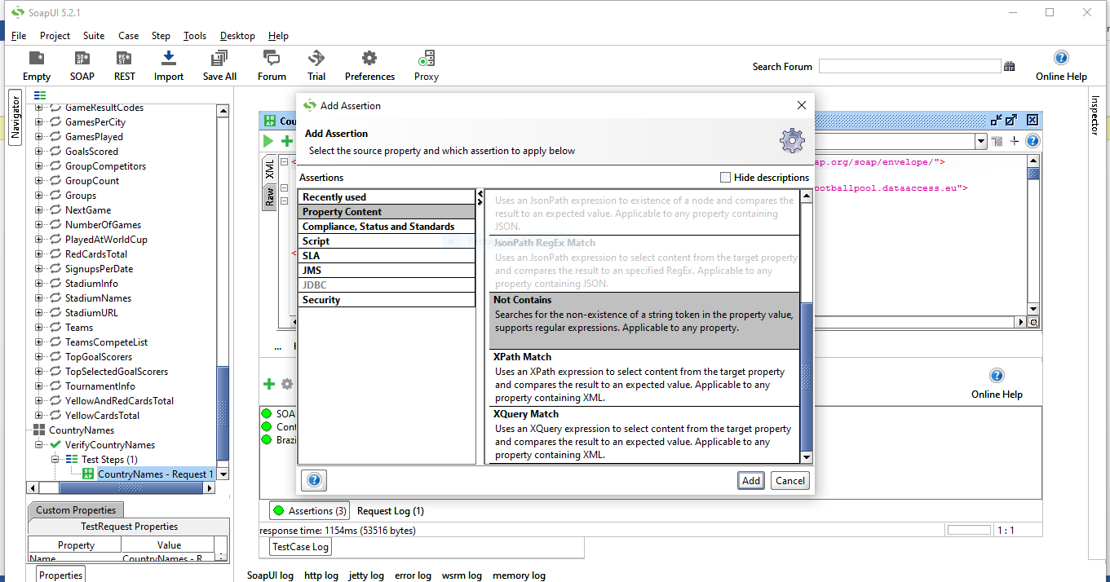

To check whether India is present in the list of countries:

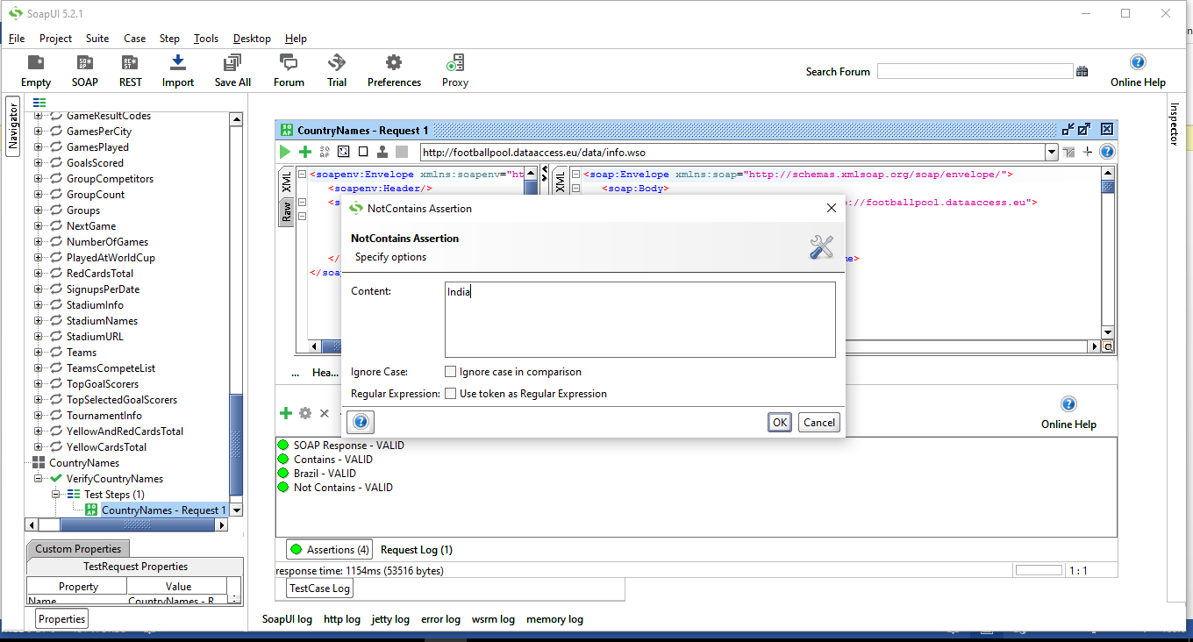

Click on OK. You see that the assertion is INVALID because, India is not present in the list of countries:

